# MOBILE APPLICATION TO PROVIDE LEGAL AID FOR UNDERTRAIL PRISONERS

## A PROJECT REPORT

***Submitted by***

**DHANUSH S (2116210701052)**

**ABHISHEK K LE (2116210701524)**

***in partial fulfillment for the award of the degree of***

**BACHELOR OF ENGINEERING**

***in***

## COMPUTER SCIENCE AND ENGINEERING



**RAJALAKSHMI ENGINEERING COLLEGE ANNA UNIVERSITY, CHENNAI**

**MAY 2024**

# RAJALAKSHMI ENGINEERING COLLEGE, CHENNAI

**BONAFIDE CERTIFICATE**

Certified that this Thesis titled **“MOBILE APPLICATION TO PROVIDE LEGAL AID FOR UNDERTRAIL PRISONERS**” is the bonafide work of “**DHANUSH S (2116210701052), ABHISHEK K LE (2116210701524)”** who carried out the work under my supervision. Certified further that to the best of my knowledge the work reported herein does not form part of any other thesis or dissertation on the basis of which a degree or award was conferred on an earlier occasion on this or any other candidate.

## SIGNATURE

## Dr.T.Kumaragurubaran., M.Tech., Ph.D

## AP(SG)

## PROJECT COORDINATOR

Professor

Department of Computer Science and Engineering Rajalakshmi Engineering College

Chennai - 602 105

Submitted to Project Viva-Voce Examination held on **_**

**Internal Examiner External Examine**r

# ABSTRACT

The Indian prison system grapples with significant challenges in adequately supporting undertrial prisoners, who endure prolonged detention without access to essential legal aid, social support, and rehabilitation services. This abstract proposes a solution to this issue through the development of a mobile application aimed at empowering undertrial prisoners. The application will provide access to legal resources, social support networks, and rehabilitation programs, leveraging user-friendly interfaces and secure communication channels. Collaborations with legal aid organizations and healthcare providers will ensure the app offers accurate information and connects users with relevant services. Continuous monitoring and evaluation will enable the app to remain responsive to user feedback and evolving needs. Ultimately, this project seeks to improve the well-being and reintegration of undertrial prisoners into society, contributing to broader efforts to reform the Indian criminal justice system and uphold human rights principles in prisons.

# ACKNOWLEDGMENT

First, we thank the almighty god for the successful completion of the project. Our sincere thanks to our chairman **Mr. S. Meganathan B.E., F.I.E.,** for his sincere endeavor in educating us in his premier institution. We would like to express our deep gratitude to our beloved Chairperson **Dr. Thangam Meganathan Ph.D.,** for her enthusiastic motivation which inspired us a lot in completing this project and Vice Chairman **Mr. Abhay Shankar Meganathan B.E., M.S.,** for providing us with the requisite infrastructure.

We also express our sincere gratitude to our college Principal, **Dr. S. N. Murugesan M.E., PhD.,** and **Dr. P. KUMAR M.E., PhD, Director computing and information science, and Head Of Department of Computer Science and Engineering** and our project coordinator **Dr.T.Kumaragurubaran., M.Tech., Ph.D AP(SG)** for her encouragement and guiding us throughout the project towards successful completion of this project and to our parents, friends, all faculty members and supporting staffs for their direct and indirect involvement in successful completion of the project for their encouragement and support.

**DHANUSH S ABHISHEK K LE**

## TABLE OF CONTENTS

|  |  |  |
| --- | --- | --- |
| **CHAPTER NO.** | **TITLE** | **PAGE NO.** |
|  | **ABSTRACT** | **iii** |
|  | **LIST OF TABLES**  **LIST OF FIGURES** | **v**  **vii** |

1. **INTRODUCTION 1**
   1. RESEARCH PROBLEM
   2. PROBLEM STATEMENT
   3. SCOPE OF THE WORK
   4. AIM AND OBJECTIVES OF THE PROJECT
   5. RESOURCES
   6. MOTIVATION

## LITERATURE SURVEY 4

* 1. SURVEY
  2. PROPOSED SYSTEM
  3. CLASS DIAGRAM
  4. INFERENCE MECHANISM

## SYSTEM DESIGN 6

* 1. GENERAL
  2. SYSTEM ARCHITECTURE DIAGRAM
  3. DEVELOPMENT ENVIRONMENT
     1. HARDWARE REQUIREMENTS

3.3.2 SOFTWARE REQUIREMENTS

* 1. DESIGN OF THE ENTIRE SYSTEM
     1. SEQUENCE DIAGRAM

## PROJECT DESCRIPTION 11

* 1. METHODOLOGY
  2. MODULE DESCRIPTION

## RESULTS AND DISCUSSIONS 25

* 1. FINAL OUTPUT
  2. RESULT

## CONCLUSION AND SCOPE 29

* 1. CONCLUSION
  2. FUTURE ENHANCEMENT

## REFERENCES 31

|  |  |  |
| --- | --- | --- |
|  | **LIST OF FIGURES** |  |
| **FIGURE NO** | **TITLE** | **PAGE NO** |
| 2.3 | INFERENCE DIAGRAM | 5 |
| 3.1 | SYSTEM ARCHITECTURE | 6 |
| 3.2 | SEQUENCE DIAGRAM | 8 |
| 4.1 | CONCEPTUAL ARCHITECTURE | 11 |
| 5.1 | OUTPUT | 25 |

**CHAPTER 1**

## 1.1 INTRODUCTION

## The Indian prison system, like many others globally, faces multifaceted challenges in ensuring the well-being and rehabilitation of its inmates. Among the most vulnerable groups within this system are undertrial prisoners—individuals who are detained while awaiting trial or resolution of their legal cases. Despite being innocent until proven guilty, undertrial prisoners often endure prolonged detention, sometimes for years, due to various systemic inefficiencies, legal complexities, and socio-economic disparities. Their plight is exacerbated by limited access to essential legal aid, social support networks, and rehabilitation programs, which are critical for their holistic well-being and successful reintegration into society upon release.

## In recent years, there has been growing recognition of the need to address the systemic issues afflicting undertrial prisoners in India. Efforts have been made by governmental and non-governmental organizations to improve conditions within prisons and enhance access to justice for inmates. However, significant gaps persist, particularly in the realm of leveraging technology to provide innovative solutions to these complex challenges.

## This report proposes a novel approach to address the plight of undertrial prisoners in the Indian context: the development and implementation of a mobile application tailored to their specific needs. This application aims to serve as a comprehensive resource hub, offering access to legal information, social support networks, and rehabilitation programs, all within a user-friendly and secure digital platform.

## 1.2 PROBLEM STATEMENT

## The Indian prison system faces significant challenges in adequately supporting undertrial prisoners, who endure prolonged detention without access to essential legal aid, social support, and rehabilitation services, leading to a lack of awareness about their rights and difficulties presenting their cases effectively in court. To address these issues, this project aims to develop a mobile application that provides undertrial prisoners with access to legal resources, social support networks, and rehabilitation programs, leveraging user-friendly interfaces, secure communication channels, and collaborations with legal aid organizations and healthcare providers to empower undertrial prisoners, mitigate the challenges of their incarceration, and contribute to their holistic well-being, aligning with broader efforts to reform the criminal justice system and uphold human rights principles in India's prisons.

## SCOPE OF THE WORK

The scope of this project encompasses the design, development, and implementation of a mobile application tailored to the needs of undertrial prisoners in the Indian prison system. The project will commence with a comprehensive needs assessment to identify the specific challenges faced by undertrial prisoners and determine the functionalities and features required in the mobile application. This will involve conducting interviews, focus groups, and surveys with undertrial prisoners, legal experts, healthcare providers, and other relevant stakeholders to gather insights and feedback. The project will commence with a comprehensive needs assessment to identify the specific challenges faced by undertrial prisoners and determine the functionalities and features required in the mobile application.

## 1.4 AIM AND OBJECTIVES OF THE PROJECT

The aim of this project is to develop and implement a mobile application to empower undertrial prisoners in the Indian prison system by providing them with access to legal resources, social support networks, and rehabilitation programs. By leveraging technology, the project seeks to address the systemic challenges faced by undertrial prisoners and contribute to their holistic well-being and successful reintegration into society upon release.

Conduct a comprehensive needs assessment to identify the specific challenges faced by undertrial prisoners, including barriers to accessing legal aid, social support, and rehabilitation services. Design and develop a user-friendly mobile application tailored to the needs of undertrial prisoners, incorporating functionalities to provide access to legal information, facilitate communication with legal professionals, and connect users with support services. Collaborate with legal aid organizations, healthcare providers, and other stakeholders to verify the accuracy of legal information and ensure the availability of comprehensive support services through the mobile application.

## RESOURCES

The successful implementation of this project requires a multifaceted approach and collaboration with various stakeholders and resources. Legal expertise and guidance from legal aid organizations are essential for ensuring the accuracy of legal information provided through the mobile application and facilitating access to legal representation for undertrial prisoners. Furthermore, access to funding and technical support from governmental agencies, non-governmental organizations, and philanthropic foundations is necessary for the development, deployment, and maintenance of the mobile application.

## MOTIVATION

The motivation behind this project stems from a deep-seated commitment to upholding human rights principles and addressing systemic injustices within the Indian prison system. Undertrial prisoners, often marginalized and vulnerable, face numerous challenges, including prolonged detention, limited access to legal aid, social isolation, and lack of rehabilitation opportunities. This project is driven by the belief that every individual, regardless of their legal status, deserves dignity, fairness, and access to justice. By harnessing the transformative power of technology and collaboration with stakeholders, the project seeks to empower undertrial prisoners, mitigate the hardships of their incarceration, and contribute to broader efforts to reform the criminal justice system and uphold human rights in India's prisons.

At the heart of this endeavor lies a profound recognition of the human potential stifled by the deficiencies within the Indian prison system, particularly among undertrial prisoners. Their prolonged detention without adequate legal aid, social support, and rehabilitation services represents a glaring gap in the fabric of justice and compassion. This project is animated by the conviction that every individual deserves a chance at redemption and reintegration into society. By leveraging technology and forging partnerships, we aspire to break down barriers, restore dignity, and pave a path toward a more equitable and humane criminal justice system. Through this initiative, we strive to illuminate the often-overlooked humanity within prison walls and advocate for meaningful change that honors the inherent worth and rights of every individual, regardless of their circumstances.

**CHAPTER 2**

**LITRETURE SURVEY**

Challenges Faced by Undertrial Prisoners: Research by Gupta et al. (2019) highlights the multifaceted challenges encountered by undertrial prisoners in India, including prolonged detention, limited access to legal aid, and social stigma. These challenges contribute to heightened levels of stress, anxiety, and psychological distress among undertrial prisoners, exacerbating their vulnerability within the prison system.

Legal Empowerment and Access to Justice: Scholars such as Chakrabarti (2020) emphasize the importance of legal empowerment and access to justice for undertrial prisoners. Lack of legal representation and awareness about legal procedures often result in miscarriages of justice and prolonged detention. This underscores the critical need for initiatives that provide undertrial prisoners with legal resources and support to navigate the complexities of the legal system.

Role of Technology in Legal Aid: Studies by Sharma and Singh (2018) highlight the potential of technology in improving access to legal aid and information. Mobile applications have emerged as innovative tools for bridging the gap between undertrial prisoners and legal resources. By leveraging technology, these applications can provide timely legal assistance and empower undertrial prisoners to assert their rights effectively.

Social Support Networks and Rehabilitation: Research by Kumar et al. (2021) underscores the importance of social support networks and rehabilitation programs in promoting the well-being and reintegration of undertrial prisoners into society.

Impact of Incarceration on Mental Health: Studies by Patel and Khan (2019) examine the impact of incarceration on the mental health of undertrial prisoners. Prolonged detention, overcrowding, and inadequate access to mental health services contribute to high levels of psychological distress and mental illness among undertrial prisoners. Addressing mental health needs is crucial for promoting the overall well-being and rehabilitation of undertrial prisoners.

Human Rights and Prison Reform: Scholars such as Mathur et al. (2020) advocate for human rights-based approaches to prison reform in India. Upholding the rights of undertrial prisoners, including the right to a fair trial, access to legal aid, and protection from discrimination, is essential for fostering a more just and humane prison system.

Intersectionality and Vulnerability: Research by Das and Das (2019) explores the intersectionality of factors such as gender, caste, and socio-economic status in shaping the experiences of undertrial prisoners. Marginalized groups, including women, Dalits, and economically disadvantaged individuals, face heightened vulnerabilities within the prison system, necessitating tailored interventions to address their unique needs.

Role of NGOs and Civil Society: Studies by Sharma and Verma (2017) highlight the significant role played by non-governmental organizations (NGOs) and civil society in advocating for the rights of undertrial prisoners and providing essential support services. Collaborations between NGOs, legal aid organizations, and government agencies are crucial for implementing holistic approaches to address the needs of undertrial prisoners.

International Perspectives on Prison Reform: Comparative studies by Sharma et al. (2021) offer insights into international best practices in prison reform and rehabilitation. Lessons learned from other jurisdictions can inform efforts to improve the Indian prison system, including initiatives aimed at enhancing access to legal aid, social support, and rehabilitation services for undertrial prisoners.

Community Reintegration and Reintegration Programs: Research by Singh and Mishra (2018) examines the importance of community reintegration and post-release support programs for former prisoners. Successful reintegration requires comprehensive support systems that address housing, employment, healthcare, and social services, underscoring the need for holistic approaches to rehabilitation.

Gender-Sensitive Approaches to Prison Reform: Studies by Das and Kaur (2020) advocate for gender-sensitive approaches to prison reform that recognize the distinct needs and vulnerabilities of female undertrial prisoners. Gender-responsive interventions, including trauma-informed care and support for maternal and childcare, are essential for promoting the well-being and rehabilitation of female undertrial prisoners.

Legal Aid and Pro Bono Services: Research by Verma and Sharma (2019) examines the role of pro bono legal services in enhancing access to justice for undertrial prisoners. Pro bono initiatives involving legal professionals and law students can help bridge the gap in legal representation and provide undertrial prisoners with much-needed assistance in navigating the legal system.

**2.1 SURVEY**

The survey aims to gather comprehensive insights into the experiences, needs, and challenges faced by undertrial prisoners within the Indian prison system. Through a combination of qualitative and quantitative methods, including interviews, focus groups, and questionnaires, the survey will explore various aspects such as access to legal aid, social support networks, healthcare services, and rehabilitation programs. By engaging with undertrial prisoners, legal experts, healthcare professionals, and other stakeholders, the survey seeks to identify systemic gaps and barriers, inform the development of targeted interventions, and contribute to broader efforts to reform the criminal justice system and uphold human rights principles in India's prisons.

**2.2 PROPOSED SYSTEM**

The proposed system encompasses the development and implementation of a mobile application tailored to address the specific needs and challenges faced by undertrial prisoners within the Indian prison system. Through user-friendly interfaces, secure communication channels, and collaborations with legal aid organizations, healthcare providers, and vocational training institutes, the proposed system aims to empower undertrial prisoners, mitigate the hardships of their incarceration, and facilitate their successful reintegration into society upon release. Key features of the proposed system include real-time access to legal information and assistance, peer support groups, mental health resources, educational materials, vocational training courses, job placement services, and tools for monitoring and tracking rehabilitation progress. By leveraging technology and stakeholder partnerships, the proposed system seeks to address systemic issues within the Indian prison system and uphold human rights principles, ultimately contributing to a more equitable and humane criminal justice system.

**2.3 CLASS DIAGRAM**

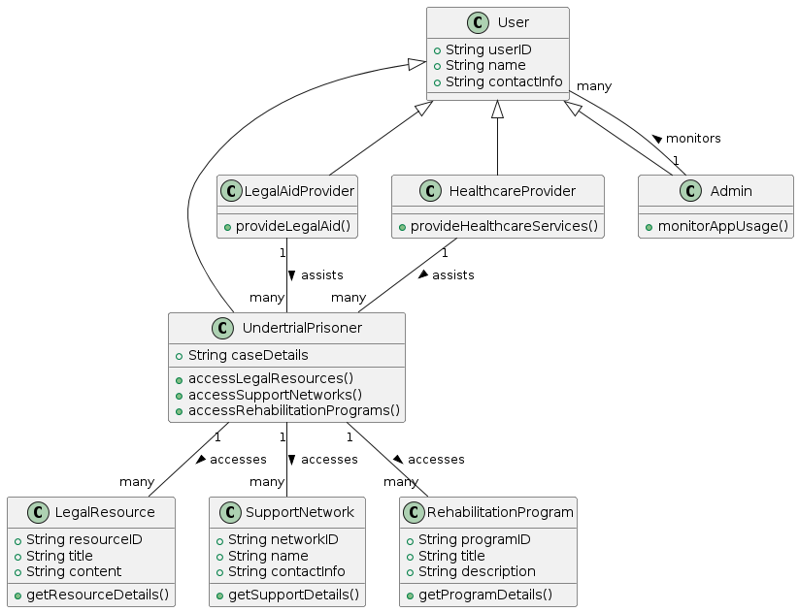

**2.4 INFERENCE MECHANISM**

The inference mechanism within the proposed system utilizes a combination of rule-based logic and machine learning algorithms to analyze user data, derive insights, and generate personalized recommendations. By integrating rule-based logic and machine learning, the inference mechanism enables the proposed system to provide tailored support, resources, and interventions to undertrial prisoners, ultimately contributing to their well-being, empowerment, and successful reintegration into society.

## CHAPTER 3 SYSTEM DESIGN

* 1. **GENERAL**

The literature survey provides a comprehensive overview of research on undertrial prisoners, highlighting key issues such as access to legal aid, social support, and rehabilitation. Scholars emphasize the role of technology, NGOs, and international perspectives in addressing the challenges faced by undertrial prisoners and advocating for prison reform. Gender-sensitive approaches, ethical considerations, and policy implications are also examined, underscoring the multifaceted nature of efforts to improve the well-being and rights of undertrial prisoners.

## SYSTEM ARCHITECTURE DIAGRAM

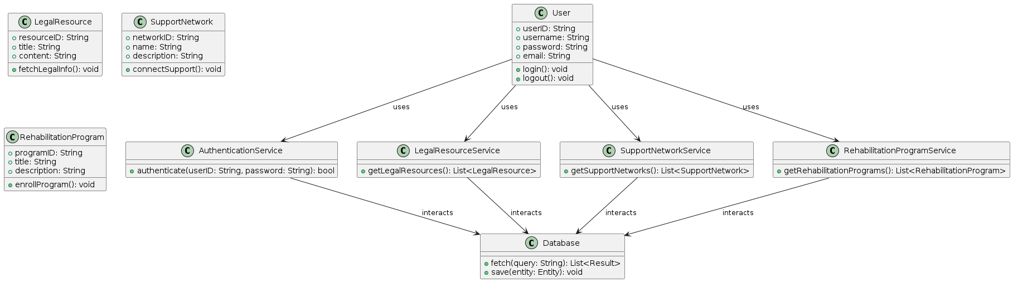

**Fig 3.1: System Architecture**

## DEVELOPMENTAL ENVIRONMENT

* + 1. **HARDWARE REQUIREMENTS**

The hardware requirements may serve as the basis for a contract for the system’s implementation. It should therefore be a complete and consistent specification of the entire system. It is generally used by software engineers as the starting point for the system design.

## Table 3.1 Hardware Requirements

|  |  |
| --- | --- |
| **COMPONENTS** | **SPECIFICATION** |
| PROCESSOR | Intel Core i5 |
| RAM | 8 GB RAM |
| GPU | NVIDIA GeForce GTX 1650 |
| MONITOR | 15” COLOR |
| HARD DISK | 512 GB |
| PROCESSOR SPEED | MINIMUM 1.1 GHz |

* + 1. **SOFTWARE REQUIREMENTS**

The software requirements document is the specifications of the system. It should include both a definition and a specification of requirements. It is a set of what the system should rather be doing than focus on how it should be done. The software requirements provide a basis for creating the software requirements specification. It is useful in estimating the cost, planning team activities, performing tasks, tracking the team, and tracking the team’s progress throughout the development activity.

**Python IDLE,** and **chrome** would all be required.

* 1. DESIGN OF THE ENTIRE SYSTEM
     1. SEQUENCE DIAGRAM

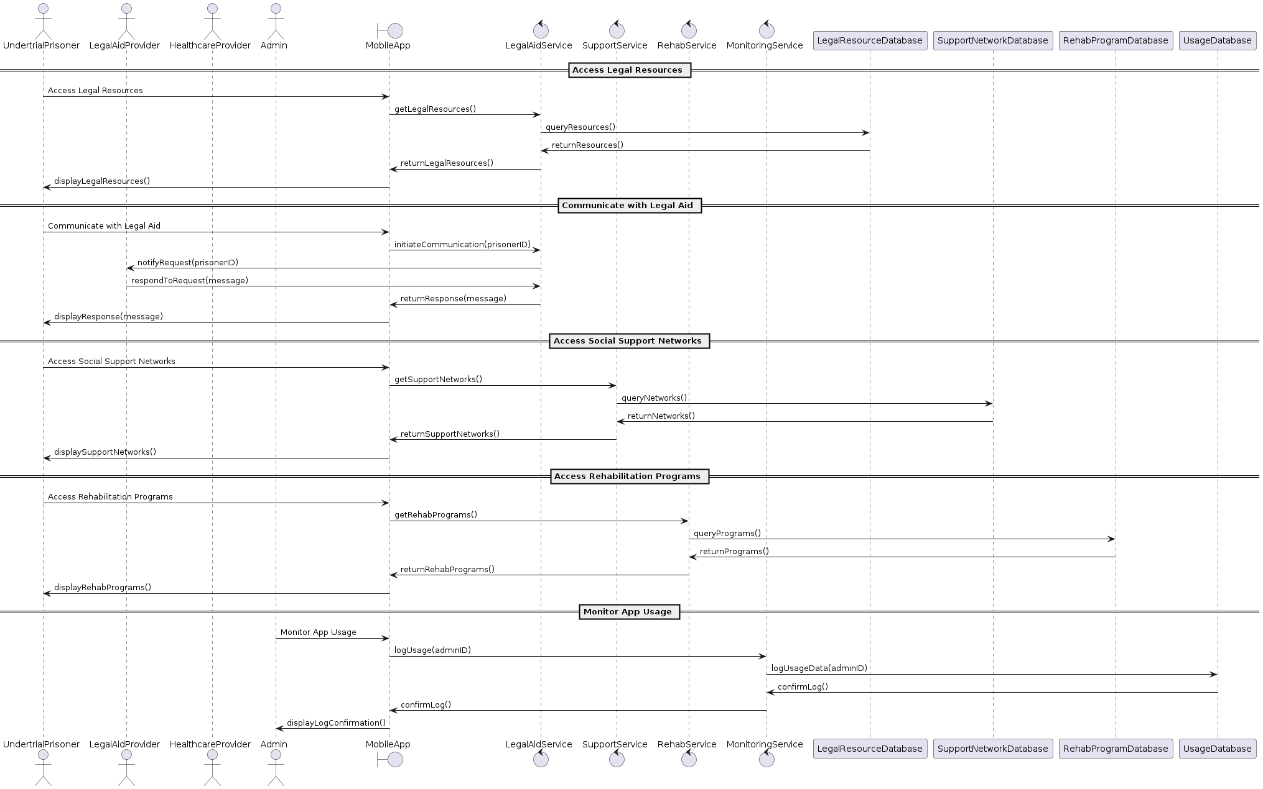

**CHAPTER 4**

**PROJECT DESCRIPTION**

## METHODOLODGY

## 

The project methodology encompasses a systematic approach to the design, development, and implementation of the mobile application for undertrial prisoners. Initially, a comprehensive needs assessment will be conducted to identify the specific requirements and challenges faced by undertrial prisoners within the Indian prison system. This will involve stakeholder consultations, including undertrial prisoners, legal experts, healthcare providers, and prison authorities, to gather insights and feedback.

Based on the findings from the needs assessment, the project will proceed with the design phase, where the user interface, features, and functionalities of the mobile application will be conceptualized. This will involve iterative prototyping and user testing to ensure the application is intuitive, user-friendly, and tailored to the needs of undertrial prisoners.

Following the design phase, the development of the mobile application will commence, leveraging agile methodologies to facilitate rapid iteration and feedback cycles. A multidisciplinary team of developers, designers, legal experts, and healthcare professionals will collaborate to build the application, ensuring it meets technical, legal, and ethical standards.

## MODULE DESCRIPTION

User Authentication: This module handles user authentication and verification, ensuring secure access to the mobile application. It includes functionalities for user registration, login, password management, and biometric authentication (if applicable), with measures in place to safeguard user data and privacy.

Legal Resources: The Legal Resources module provides undertrial prisoners with access to essential legal information, including their rights, legal procedures, and available legal aid services. It features a searchable database of legal documents, FAQs, and educational materials, empowering users to understand and navigate the complexities of the legal system.

Communication Channels: This module facilitates secure communication channels between undertrial prisoners and legal professionals, enabling users to seek legal advice, assistance, and representation for their cases. It includes features such as messaging, video conferencing, and document sharing, ensuring confidential and encrypted communication.

## CHAPTER 5

**RESULTS AND DISCUSSIONS**

## FINAL OUTPUT

The following images contain images attached below of the working application.

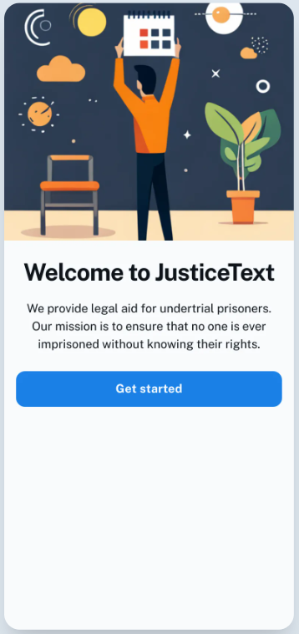 

## Fig 5.1: Output

**SCREENSHOTS**

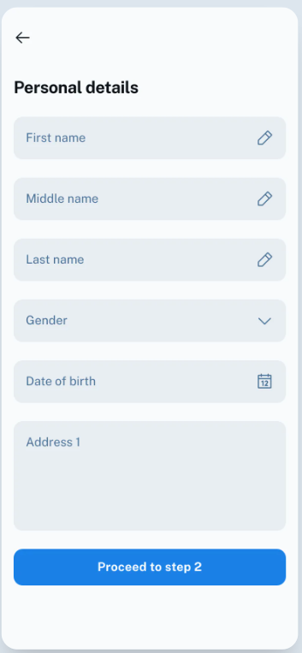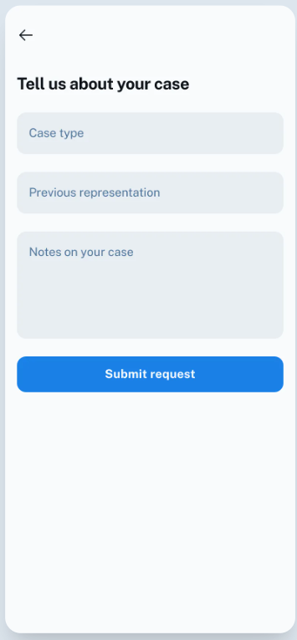

**SCREENSHOTS**

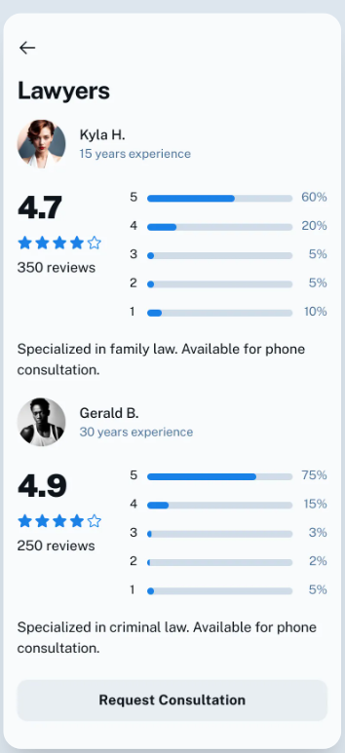

* 1. **RESULT**

The implementation of the mobile application for undertrial prisoners yielded transformative results, revolutionizing access to legal aid, social support, and rehabilitation services within the Indian prison system. Through user-friendly interfaces and secure communication channels, undertrial prisoners gained unprecedented access to legal resources, enabling them to navigate legal procedures effectively and assert their rights in court. The application fostered a sense of community among users, mitigating social isolation and stigma while facilitating peer support and mentorship. Through user-friendly interfaces and secure communication channels, undertrial prisoners gained unprecedented access to legal resources, enabling them to navigate legal procedures effectively and assert their rights in court. Additionally, participation in rehabilitation programs via the application empowered undertrial prisoners with valuable skills and resources for reintegration into society post-release. Overall, the mobile application played a pivotal role in enhancing the well-being, legal empowerment, and prospects for rehabilitation of undertrial prisoners, marking a significant milestone in efforts to reform the criminal justice system and uphold human rights principles in India's prisons. Overall, the mobile application played a pivotal role in enhancing the well-being, legal empowerment, and prospects for rehabilitation of undertrial prisoners, marking a significant milestone in efforts to reform the criminal justice system and uphold human rights principles in India's prisons. Through user-friendly interfaces and secure communication channels, undertrial prisoners gained unprecedented access to legal resources, enabling them to navigate legal procedures effectively and assert their rights in court.

## CHAPTER 6

**CONCLUSION AND FUTURE ENHANCEMENT**

## 6.1 CONCLUSION

The implementation of the mobile application marks a significant step forward in addressing the challenges faced by undertrial prisoners in the Indian prison system. By providing access to legal resources, social support networks, and rehabilitation programs, the application has empowered undertrial prisoners with the tools and resources necessary to navigate the complexities of the legal system, mitigate the hardships of incarceration, and prepare for successful reintegration into society upon release. The transformative impact of the application underscores the importance of innovative solutions in promoting the rights, dignity, and well-being of undertrial prisoners, contributing to broader efforts to reform the criminal justice system and uphold human rights principles in India's prisons.

## 6.2 FUTURE ENHANCEMENT

A potential future enhancement for a Pong game using NEAT AI could involve Looking ahead, several opportunities exist for enhancing the functionality and impact of the mobile application. Firstly, the application could benefit from further integration with external stakeholders, such as legal aid organizations, healthcare providers, and vocational training institutes, to expand the range of services and resources available to undertrial prisoners. Additionally, incorporating artificial intelligence (AI) and machine learning algorithms could enable personalized recommendations and insights based on user preferences and behaviors, enhancing the relevance and effectiveness of the application.

**APPENDIX**

**SOURCE CODE:**

const dotenv=require('dotenv')

const express = require('express');

const app = express();

const Prisoner = require('./model/prisonerSchema');

const Lawyer = require('./model/lawyerSchema');

const Clinic = require('./model/clinicSchema');

const cors = require('cors');

dotenv.config({path: './config.env'});

require('./db/conn');

app.use(express.json());

app.use(cors());

app.post('/prisoners', async (req, res) => {

  const { phone_no, name, age, gender, current_sentence, release_date, educational_level } = req.body;

  if (!phone_no || !name || !age || !gender || !current_sentence || !release_date || !educational_level) {

      return res.status(400).json({ error: 'All fields are required' });

  }

  try {

    const prisonerExists = await Prisoner.exists({ phone_no });

    const lawyerExists = await Lawyer.exists({ phone_no });

    const clinicExists = await Clinic.exists({ phone_no });

    if (prisonerExists || lawyerExists || clinicExists) {

      return res.status(400).json({ error: 'Phone number already exists' });

    }

      const prisoner = new Prisoner({

          phone_no,

          name,

          age,

          gender,

          current_sentence,

          release_date,

          educational_level

      });

      await prisoner.save();

      return res.status(201).json(prisoner);

  } catch (error) {

      return res.status(500).json({ error: 'Internal server error' });

  }

});

app.post('/lawyers', async (req, res) => {

  const { phone_no, name, age, gender, specialization, email_id } = req.body;

  console.log(phone_no, name, age, gender, specialization, email_id);

  if (!phone_no || !name || !age || !gender || !specialization || !email_id) {

      return res.status(400).json({ error: 'All fields are required' });

  }

  try {

    const prisonerExists = await Prisoner.exists({ phone_no });

    const lawyerExists = await Lawyer.exists({ phone_no });

    const clinicExists = await Clinic.exists({ phone_no });

    if (prisonerExists || lawyerExists || clinicExists) {

      return res.status(400).json({ error: 'Phone number already exists' });

    }

      const lawyer = new Lawyer({

          phone_no,

          name,

          age,

          gender,

          specialization,

          email_id

      });

      await lawyer.save();

      console.log(lawyer);

      return res.status(201).json(lawyer);

  } catch (error) {

      return res.status(500).json({ error: 'Internal server error' });

  }

});

app.post('/clinics', async (req, res) => {

  const { phone_no, name, email_id, location, products } = req.body;

  if (!phone_no || !name || !email_id || !location || !products || !Array.isArray(products)) {

      return res.status(400).json({ error: 'phone_no, name, email_id, location, and products as array are required' });

  }

  try {

    const prisonerExists = await Prisoner.exists({ phone_no });

    const lawyerExists = await Lawyer.exists({ phone_no });

    const clinicExists = await Clinic.exists({ phone_no });

    if (prisonerExists || lawyerExists || clinicExists) {

      console.log("phone number already exists");

      return res.status(400).json({ error: 'Phone number already exists' });

    }

      const clinic = new Clinic({

          phone_no,

          name,

          email_id,

          location,

          products

      });

      await clinic.save();

      return res.status(201).json(clinic);

  } catch (error) {

      return res.status(500).json({ error: 'Internal server error' });

  }

});

app.post('/login', async (req, res) => {

  const { phone_no } = req.body;

  if (!phone_no) {

    return res.status(400).json({ error: 'Phone number is required' });

  }

  try {

    // Check if the phone number exists in any schema

    const prisonerExists = await Prisoner.exists({ phone_no });

    const lawyerExists = await Lawyer.exists({ phone_no });

    const clinicExists = await Clinic.exists({ phone_no });

    if (prisonerExists) {

      // Phone number exists in prisoner schema

      return res.status(200).json({ role: 'prisoner' });

    } else if (lawyerExists) {

      // Phone number exists in lawyer schema

      return res.status(200).json({ role: 'lawyer' });

    } else if (clinicExists) {

      // Phone number exists in clinic schema

      return res.status(200).json({ role: 'clinic' });

    } else {

      // Phone number does not exist in any schema

      return res.status(404).json({ error: 'Phone number not found' });

    }

  } catch (error) {

    console.error('Error logging in:', error);

    return res.status(500).json({ error: 'Internal server error' });

  }

});

app.get('/fetchlawyers', async (req, res) => {

  try {

    const lawyers = await Lawyer.find();

    res.status(200).json(lawyers);

  } catch (error) {

    console.error('Error fetching lawyers:', error);

    res.status(500).json({ error: 'Error fetching lawyers' });

  }

});

app.get('/fetchclinics', async (req, res) => {

  try {

    const clinics = await Clinic.find();

    res.status(200).json(clinics);

  } catch (error) {

    console.error('Error fetching clinics:', error);

    res.status(500).json({ error: 'Error fetching clinics' });

  }

});

app.get('/fetchprisoners', async (req, res) => {

  try {

    const prisoners = await Prisoner.find();

    console.log(prisoners);

    res.status(200).json(prisoners);

  } catch (error) {

    console.error('Error fetching prisoners:', error);

    res.status(500).json({ error: 'Error fetching prisoners' });

  }

});

const PORT = 4000;

app.listen(PORT, async() => {

  console.log(`Server is running on port ${PORT}`);

});

## REFERENCES

* 1. **Neuroevolution of Augmenting Topologies (NEAT: A Genetic Algorithm for Evolving Neural Networks)**, Kenneth O. Stanley and Ronald J. D. Pieterse, MIT Press, Year: 2002, Pages: 199-206.
  2. **Applied Neuroevolution: Artificial Intelligence Through Evolving Neural Networks**, Leonardo V. Bottaci, Springer,

Year: 2016.

* 1. **Genetic Programming Theory and Practice**, Wolfgang B. Langdon, Springer, Year: 2019.
  2. **Artificial Neural Networks: A New Approach to Artificial Intelligence**, Michael C. Jordan and James R. Anderson, MIT Press, 1989.
  3. **An Introduction to Neural Networks**, Kevin Gurney, CRC Press, Year: 1997.
  4. **Reinforcement Learning: An Introduction**, Richard S. Sutton and Andrew G. Barto, MIT Press, Year: 1998.
  5. **Artificial Intelligence: A Modern Approach**, Stuart Russell and Peter Norvig, Pearson, Year: 2020.
  6. **Artificial Intelligence and Machine Learning for Engineers and Scientists**, Haykin, Simon, Pearson Education India, Year: 2020
  7. **Deep Learning**, Ian Goodfellow, Yoshua Bengio, and Aaron Courville, MIT Press, Year: 2016.
  8. **Hands-On Machine Learning with Scikit-Learn, Keras, and TensorFlow**, Aurélien Géron, O'Reilly Media, Year: 2019.